TOOL-AUGMENTED QUESTION-CENTRIC RETRIEVAL USING QUIM-RAG FOR RELIABLE KNOWLEDGE-GROUNDED QUESTION ANSWERING

A PROJECT REPORT

Submitted in the partial fulfillment of requirements to

R. V. R. & J. C. COLLEGE OF ENGINEERING

For the award of the degree
B. Tech. in CSE
By

Galla Durga Rama Satya Pradeep Kumar (Y22CS048)
Enadula Naga Avinash Babu (Y22CS044)



MAY, 2026

R.V.R. & J. C. COLLEGE OF ENGINEERING (Autonomous)
(Affiliated to Acharya Nagarjuna University)
Chandramoulipuram :: Chowdavaram
GUNTUR – 522019

R.V.R & J.C. COLLEGE OF ENGINEERING
(Autonomous)
DEPARTMENT OF COMPUTER SCIENCE AND ENGINEERING
CERTIFICATE



This is to certify that this project work titled “Tool-Augmented Question-Centric Retrieval Using QuIM-RAG For Reliable Knowledge-Grounded Question Answering” is the work done by Galla Durga Rama Satya Pradeep Kumar (Y22CS048) and Enadula Naga Avinash Babu (Y22CS044) under our supervision, and submitted in partial fulfilment of the requirements for the award of the degree, B. Tech. in Computer Science & Engineering, during the Academic Year 2025-2026.

Dr. M. Sreelatha Dr. G .Srinivasa Rao Dr. M. Sreelatha
Project Guide In-charge, Project Work Prof.& Head

ACKNOWLEDGEMENT

The successful completion of any task would be incomplete without proper suggestions, guidance and support. Combination of these factors acts like backbone to our project titled “Tool-Augmented Question-Centric Retrieval Using QuIM-RAG For Reliable Knowledge-Grounded Question Answering”.
We are very glad to express our special thanks to Dr. M. Sreelatha, Project Guide, who has inspired us to select this topic, and also for her valuable suggestion in completion of the project.
We are very thankful to Dr. G .Srinivasa Rao, Project In-charge who extended her encouragement and assistance in ensuring the smooth progress of the project work.
We would like to express our profound gratitude to Dr. M. Sreelatha, Head of the Department of Computer Science and Engineering for her encouragement and support to carry out this Project successfully.
We are very much thankful to Dr. Kolla Srinivas, Principal, for having allowed us to conduct the study needed for the project.
Finally we submit our heartfelt thanks to all the staff in the Department and to all our friends for their cooperation during the project work.

Galla Durga Rama Satya Pradeep Kumar (Y22CS048)
Enadula Naga Avinash Babu (Y22CS044)

ABSTRACT

Large Language Models (LLMs) have shown remarkable performance in natural language understanding and generation tasks, but they often suffer from hallucination due to reliance on parametric knowledge learned during pretraining. Retrieval-Augmented Generation (RAG) addresses this limitation by grounding generated responses in external knowledge sources. However, conventional RAG systems rely on chunk-centric retrieval over text-only corpora, which can lead to semantic mismatch, information dilution, and unreliable responses when deployed in real-world environments. To overcome these limitations, QuIM-RAG introduced a question-centric retrieval mechanism that retrieves information using generated questions instead of raw text chunks.
In this project, we extend the QuIM-RAG framework by developing a tool-augmented retrieval system capable of handling heterogeneous web-based knowledge sources. The proposed system extracts information from web text, structured HTML tables, embedded images using Optical Character Recognition (OCR), and linked PDF documents. All extracted data is normalized into a unified textual corpus and indexed using prototype-based question-centric retrieval.
The system also integrates query rewriting and cross-encoder reranking to improve retrieval quality and robustness. Retrieved evidence is provided to a language model for grounded answer generation, with refusal behavior when sufficient evidence is unavailable. Experimental evaluation using BERTScore, faithfulness, answer relevance, context precision, and harmfulness shows that the proposed system achieves competitive semantic performance with improved grounding and reliability. This project demonstrates that combining data-centric corpus construction with question-centric retrieval enables practical and trustworthy RAG systems for real-world question answering.

CONTENTS
 |  | Page No.
i | Title Page | i
ii | Certificate | ii
iii | Acknowledgement | iii
iv | Abstract | iv
v | Contents | v
vi | List of Tables | vii
vii | List of Figures | viii
viii | List of Abbreviations | ix
1. | Introduction | 1
 | 1.1 Background | 1
 | 1.2 Problem Definition | 3
 | 1.3 Significance of the work | 4
2. | Literature Review | 6
 | 2.1 Review of LLM-based QA Systems | 6
 | 2.2 Limitations of existing techniques | 13
3. | System Analysis | 14
 | 3.1 Requirements Specification | 14
 | 3.1.1 Functional Requirements | 14
 | 3.1.2 Non-Functional Requirements | 16
 | 3.1.3 System Specifications | 18
 | 3.2 UML Diagrams | 18
 | 3.2.1 Use Case Diagram | 18
 | 3.2.2 Activity Diagram | 19
 | 3.2.3 Sequence Diagram | 20
 | 3.2.4 Class Diagram | 21
 | 3.2.5 Component Diagram | 22
 | 3.2.6 Deployment Diagram | 23
4. | System Design
 | 4.1 Architecture of the proposed system | 25
 | 4.2 Workflow of the proposed system | 27
 | 4.3 Module Description | 29
5. | Implementation
 | 5.1 Algorithms | 35
 | 5.2 Data sources Used | 41
 | 5.3 Metrics calculated | 43
 | 5.4 Methods compared | 44
 | 5.5 Environment | 46
6. | Testing
 | 6.1 Unit Testing | 47
 | 6.2 Integration Testing | 48
 | 6.3 System Testing | 48
 | 6.4 Performance Testing | 49
 | 6.5 Test Case Validation | 49
7. | Result Analysis
 | 7.1 Actual Results obtained from the work | 52
 | 7.2 Analysis of the Results obtained | 57
8. | Conclusion and Future Work | 58
9. | References | 60

LIST OF TABLES

S. No | Table No. | Table Description | Page No.
1 | 5.1 | Data Sources Used | 43
2 | 5.2 | Implementation Environment | 46
3 | 6.1 | Web Text Question Answering | 49
4 | 6.2 | Table Based Retrieval | 49
5 | 6.3 | OCR Image Retrieval | 50
6 | 6.4 | PDF Based Retrieval | 50
7 | 6.5 | Unsupported Query Retrieval | 50
8 | 6.6 | Retrieval Efficiency | 51
9 | 7.1 | Comparative Performance of Retrieval Methods | 53

LIST OF FIGURES

S. No. | Figure No. | Figure Name | Page No.
1 | 1.1 | Basic working of Large Language Models | 1
2 | 1.2 | RAG Architecture | 2
3 | 2.1 | The Transformer - model architecture | 6
4 | 2.2 | Training of Llama 2-Chat | 8
5 | 2.3 | Vector DataBase Architecture | 8
6 | 2.4 | Sparse vs Dense Retrieval | 9
7 | 2.5 | QuIM – RAG Architecture | 10
8 | 2.6 | Cross Encoder | 11
9 | 2.7 | Evaluations Metrics | 12
10 | 3.1 | Use Case Diagram | 19
11 | 3.2 | Activity Diagram | 20
12 | 3.3 | Sequence Diagram | 21
13 | 3.4 | Class Diagram | 22
14 | 3.5 | Component Diagram | 23
15 | 3.6 | Deployment Diagram | 23
16 | 4.1 | Tool-Augmented Corpus Construction Pipeline | 26
17 | 4.2 | Question Centric Retreival & Grounded Answer | 26
18 | 7.2 | BertScore Comparison across methods | 54
19 | 7.3 | Faithfulness Comparison | 55
20 | 7.4 | Response Latency Comparison | 56
21 | 7.5 | Quality vs Reliability Trade-off | 56
LIST OF ABBREVIATIONS

1. AI | - | Artificial Intelligence
2. API | - | Application Programming Interface
3. OCR | - | Optical Character Recognition
4. BERT | - | Bidirectional Encoder Representations from Transformers
5. GPU | - | Graphical Processing Unit
6. DQN | - | Deep Q-Network
7. GPT | - | Generative Pre-trained Transformer
8. LLM | - | Large Language Model
9. TF-IDF | - | Term Frequency – Inverse Document Frequency
10. NLP | - | Natural Language Processing
11. QA | - | Question Answering
12. RAG | - | Retrieval- Augmented Generation
13. RL | - | Reinforcement Learning
14. ROUGE | - | Recall-Oriented Understudy for Gisting Evaluation
15. SBert | - | Sentence-BERT
16. RAGAS | - | Retrieval-Augmented Generation Assessment Suite
17. T5 | - | Text- to- Text Transfer Transformer
18. IR | - | Information Retrieval
19. HTTPS | - | HyperText Transfer Protocol Secure

1. INTRODUCTION
1.1 Background
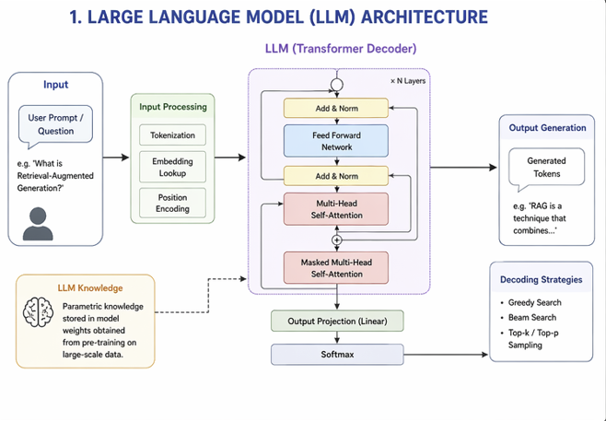
Artificial Intelligence (AI) has rapidly transformed the field of information access and intelligent question answering. In recent years, Large Language Models (LLMs) such as GPT, LLaMA, and Mistral have demonstrated remarkable capabilities in natural language understanding and response generation [1], [2]. These models are increasingly used in chatbots, educational assistants, healthcare systems, enterprise support platforms, and automated customer service solutions.

Fig 1.1 Basic working of Large Language Models
Despite their impressive performance, LLMs suffer from an important limitation known as hallucination, where the model generates fluent but factually incorrect or unsupported information [3], [4]. This issue arises because traditional LLMs rely primarily on parametric knowledge learned during pretraining, which may become outdated, incomplete, or irrelevant to a specific domain.
To overcome this limitation, Retrieval-Augmented Generation (RAG) was introduced as a powerful framework that combines external knowledge retrieval with language generation [5]. Instead of answering solely from memorized model knowledge, RAG retrieves relevant documents from an external knowledge base and uses them as supporting evidence for answer generation. This significantly improves factual grounding and reliability.

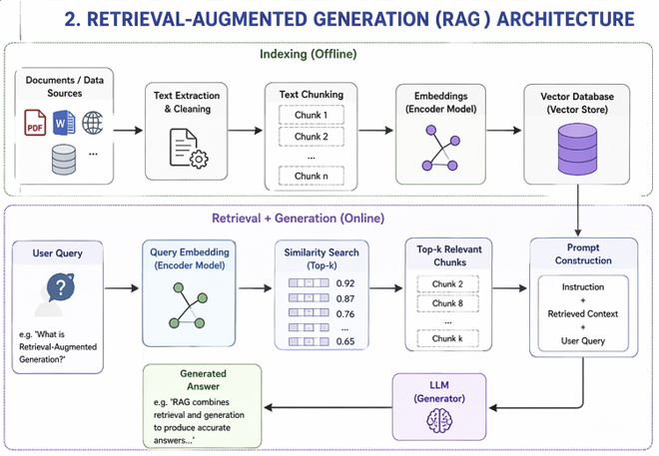
Fig 1.2 Retrieval-Augmented Generation (RAG) architecture
However, most conventional RAG systems rely on chunk-centric retrieval, where documents are divided into fixed-size text chunks and matched directly against user queries using vector similarity [5]. Although effective in many cases, chunk-based retrieval introduces several practical problems:
- Semantic mismatch: Retrieved chunks may contain related keywords but fail to match the true meaning of the query.
- Information dilution: Multiple loosely related chunks may be retrieved, reducing answer quality.
- Hallucination risk: If the retrieved context is weak or irrelevant, the model may still generate unsupported responses.
- Limited data coverage: Most systems focus only on plain text documents.
To address these limitations, the QuIM-RAG framework proposed a question-centric retrieval approach [6]. Instead of indexing raw document chunks, representative questions are automatically generated from each chunk. User queries are then matched against these indexed questions, leading to stronger semantic alignment and more accurate retrieval.
Although QuIM-RAG improves retrieval precision, it mainly assumes clean and preprocessed textual corpora [6]. In real-world environments such as universities, companies, hospitals, and government organizations, knowledge is often distributed across multiple heterogeneous sources, including:
- Web pages
- Structured HTML tables
- Embedded images containing text
- Scanned forms and notices
- Linked PDF documents
- Semi-structured web portals
Traditional RAG and original QuIM-RAG systems do not fully address these practical data challenges.
To solve this gap, the present project proposes Tool-Augmented Question-Centric Retrieval Using QuIM-RAG for Reliable Knowledge-Grounded Question Answering. The system extends QuIM-RAG through a practical pipeline that automatically extracts knowledge from heterogeneous sources using multiple tools such as OCR, PDF parsers, HTML table extractors, and web crawlers. The extracted content is normalized into a unified corpus and indexed using prototype-based question-centric retrieval.
In addition, the proposed system includes:
- Query Rewriting for ambiguous or short user queries
- Cross-Encoder Reranking for improved ranking precision [7]
- Grounded Answer Generation using retrieved evidence
- Refusal Mechanism when sufficient evidence is unavailable
The main objective of this project is to build a reliable, scalable, and domain-ready intelligent question answering system capable of operating in real-world knowledge environments.
1.2 Problem Definition
Modern knowledge-based question-answering systems built on Large Language Models (LLMs) face several practical limitations when deployed in real-world environments. Although LLMs are capable of generating fluent and contextually rich responses, they often rely on parametric knowledge learned during pretraining, which may be outdated, incomplete, or inaccurate. As a result, such systems are prone to hallucination, where confident but unsupported answers are generated. This reduces trustworthiness in applications where factual accuracy is essential [1], [2].
Retrieval-Augmented Generation (RAG) was introduced to address this issue by combining LLMs with external knowledge retrieval mechanisms [3]. In a typical RAG pipeline, relevant documents or text chunks are retrieved from a corpus and supplied as context for answer generation. While this improves factual grounding, most existing RAG systems depend on chunk-centric retrieval, where fixed-size document segments are directly matched with user queries. This introduces several inefficiencies and retrieval limitations.
One major problem is semantic mismatch. A user query may express intent differently from the wording present inside document chunks. Even when a chunk contains the correct answer, direct chunk matching may fail to retrieve it effectively. Conversely, retrieved chunks may contain overlapping keywords but not the actual information needed for the query.
Another challenge is information dilution. Traditional systems often retrieve multiple chunks for a single query, many of which may be only partially relevant. When these chunks are passed to the LLM, the model must process unnecessary context, increasing token consumption, latency, and the possibility of generating noisy or mixed responses.
Existing systems also struggle with heterogeneous knowledge sources. In real-world organizations, useful information is not limited to plain text documents. Important content is frequently available in structured HTML tables, notices embedded in images, scanned forms, charts, and linked PDF documents. Conventional RAG pipelines are primarily designed for text retrieval and do not efficiently utilize these multimodal or semi-structured data sources.
Although the QuIM-RAG framework improved retrieval quality through a question-centric indexing mechanism, it mainly assumes clean and preprocessed textual corpora. It does not fully address practical deployment challenges such as automated web data acquisition, extraction from images and PDFs, or robust retrieval under ambiguous user queries.
Therefore, there is a need for an intelligent and scalable question-answering framework that can automatically construct a knowledge corpus from heterogeneous sources, perform semantically aligned retrieval, reduce irrelevant context, and generate trustworthy grounded responses. Addressing these challenges is essential for deploying reliable Retrieval-Augmented Generation systems in real-world institutional and enterprise environments.
  - Significance of the work
- Improved Reliability and Reduced Hallucination: One of the major limitations of standalone LLMs is the generation of unsupported or factually incorrect responses. This work improves reliability by grounding generated answers in retrieved external evidence, thereby reducing hallucination and increasing trustworthiness.
- Question-Centric Semantic Retrieval: Unlike traditional chunk-based retrieval systems, the proposed framework adopts a question-centric retrieval strategy. By indexing representative questions instead of raw text chunks, the system achieves stronger semantic alignment between user intent and retrieved knowledge.
- Integration of Heterogeneous Knowledge Sources: Real-world knowledge is distributed across multiple formats such as web text, structured tables, images, and PDF documents. This work introduces a tool-augmented corpus construction pipeline that unifies these diverse sources into a searchable knowledge base.
- Efficient Retrieval through Prototype-Based Indexing: The use of prototype clustering and inverted indexing reduces the effective search space during inference. This improves retrieval speed, lowers computational overhead, and supports scalable deployment over growing corpora.
- Enhanced Query Understanding and Ranking: By incorporating query rewriting and cross-encoder reranking, the system handles ambiguous or underspecified queries more effectively and improves final evidence ranking precision.
- Practical Applicability in Real-World Domains: The proposed framework is suitable for universities, enterprises, government portals, legal systems, and customer support environments where information exists across multiple formats and answer reliability is critical.
- Foundation for Future Intelligent Systems: This work provides a strong foundation for future extensions such as multilingual retrieval, voice-enabled assistants, adaptive prototype learning, and continuously updating enterprise knowledge systems.
Overall, this work contributes toward improving the efficiency, scalability, and effectiveness of document-based question-answering systems by introducing a unified, adaptive, and multimodal approach to context selection and compression.

2. LITERATURE REVIEW
2.1 Review of LLM-based QA Systems
The rapid growth of Large Language Models (LLMs) has significantly transformed intelligent question-answering systems. Researchers have proposed multiple retrieval and generation frameworks to improve factual reliability, semantic relevance, and practical usability. This section presents a detailed review of important research works related to Retrieval-Augmented Generation (RAG), lexical and dense retrieval methods, question-centric retrieval, vector databases, multimodal knowledge extraction, reranking techniques, and evaluation frameworks. These studies provide the foundation for the proposed Tool-Augmented QuIM-RAG system.
2.1.1 Transformer-Based LLM Architectures
Vaswani et al. [16] - The Transformer model
Vaswani et al. [16] introduced the Transformer model, which revolutionized NLP by replacing traditional recurrent architectures with a self-attention mechanism, improving both efficiency and scalability. Unlike RNNs, Transformers enable parallel processing, significantly accelerating training for large-scale language models. This breakthrough laid the foundation for modern LLMs like GPT, BERT, and T5, which have achieved remarkable success in question-answering, text generation, and machine translation. Additionally, the study introduced positional encoding to preserve word order, enhancing model accuracy.
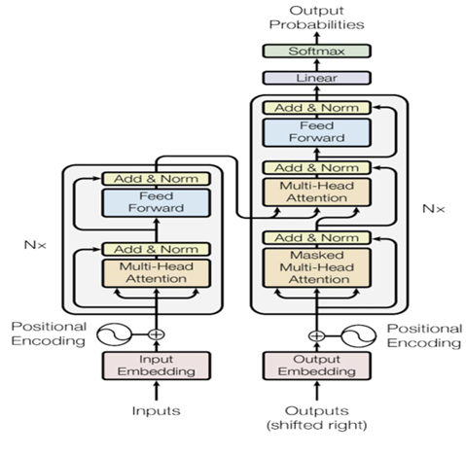
Fig 2.1 The Transformer - model architecture
The Transformer’s ability to capture long-range dependencies in text has made it the dominant architecture in state-of-the-art retrieval and QA systems. Today, it continues to drive advancements in retrieval-augmented generation (RAG) and domain-specific language models.
Brown et al. [13] - GPT-3 and Few-Shot Learning
Brown et al. [13] introduced GPT-3, a 175-billion parameter model that showcased few-shot learning, reducing reliance on task-specific fine-tuning. Unlike previous models that required extensive supervised training, GPT-3 demonstrated the ability to generalize across multiple NLP tasks with minimal examples, making it highly effective for open-domain question answering (QA), text generation, and language translation. Their study highlighted the importance of scaling language models to improve performance across tasks. However, they also identified hallucination issues, where GPT-3 generated factually incorrect but fluent responses, raising concerns about reliability in critical applications such as medicine and law. This limitation underscored the need for retrieval-based augmentation to enhance response accuracy and factual grounding.
Touvron et al. [15] - LLaMA: Efficient LLMs
Touvron et al. [15] introduced LLaMA (Large Language Model Meta AI), a model designed to be smaller yet highly efficient, achieving state-of-the-art performance despite using fewer parameters than traditional LLMs. Their research demonstrated that well-optimized smaller models can rival larger ones, making LLMs more accessible for researchers and developers with limited computational resources. LLaMA was trained using optimized tokenization and efficient training techniques, allowing it to perform competitively in various NLP tasks, including QA, summarization, and text classification. However, their study acknowledged that LLaMA, like other LLMs, struggles with domain-specific QA without external retrieval mechanisms. This limitation reinforced the importance of integrating retrieval-based approaches, such as RAG, to enhance precision and factual accuracy in domain-specific applications.
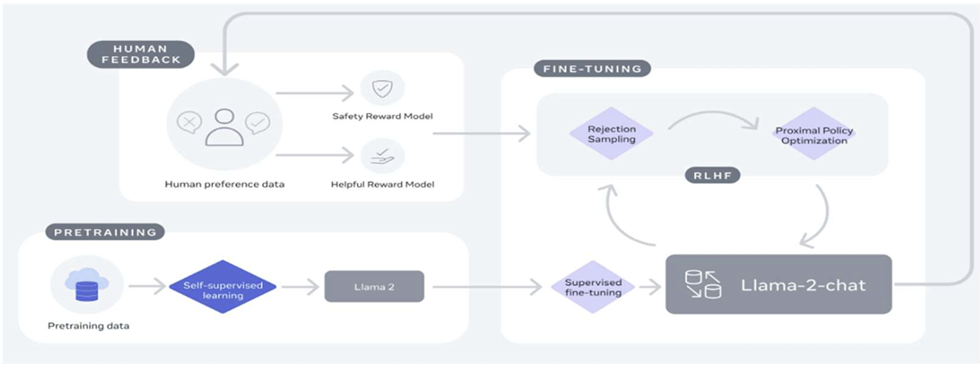
Fig 2.2 Training of Llama 2-Chat
2.1.2 Retrieval-Augmented Generation and Vector Databases
Efficient retrieval mechanisms are essential for improving answer quality in LLM-based systems. Instead of depending only on model memory, modern systems retrieve external evidence from knowledge bases and use it during answer generation.
Lewis et al. (2020) [1] – Retrieval-Augmented Generation (RAG)
Lewis et al. introduced Retrieval-Augmented Generation (RAG), a framework that combines dense document retrieval with sequence-to-sequence language generation. The model retrieves relevant passages from an external corpus and conditions the generator on the retrieved evidence. This approach significantly improved factual grounding and performance in open-domain question answering.
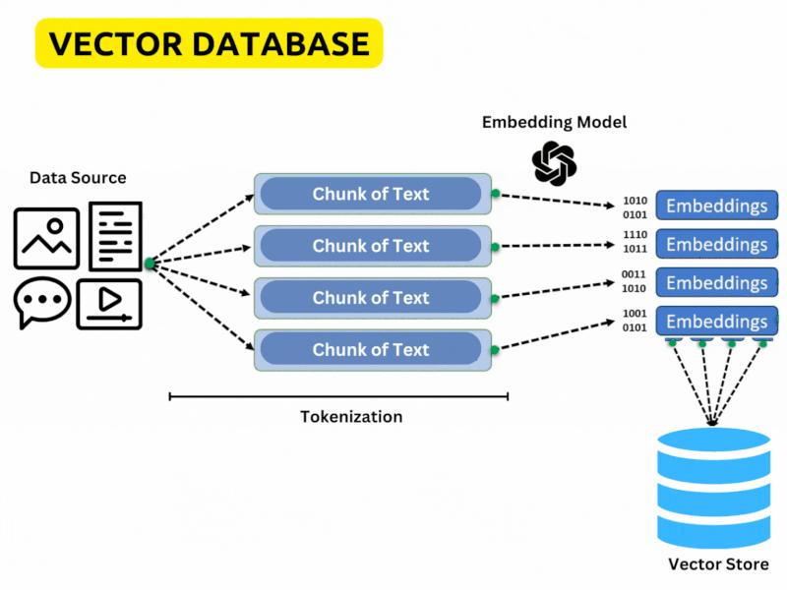
ChromaDB (2023) [2] – Vector Database

Fig 2.3 Vector DataBase Architecture
ChromaDB is an open-source vector database designed for storing embeddings and performing semantic similarity search. It supports scalable indexing, metadata filtering, and efficient nearest-neighbor retrieval, making it suitable for modern RAG pipelines and enterprise knowledge systems.
2.1.3 Lexical and Dense Retrieval Methods
Traditional search systems and modern semantic retrieval methods both play important roles in question-answering pipelines.
Robertson et al. [3] – BM25 Retrieval Model
BM25 is one of the most widely used lexical retrieval models. It ranks documents based on keyword frequency, inverse document frequency, and document length normalization. BM25 remains a strong baseline in information retrieval systems due to its speed and simplicity.
Karpukhin et al. (2020) [4] – Dense Passage Retrieval (DPR)
Dense Passage Retrieval introduced dual-encoder semantic retrieval, where both queries and passages are embedded into the same vector space. Similarity between vectors is used to retrieve semantically relevant passages even when exact keywords are absent.
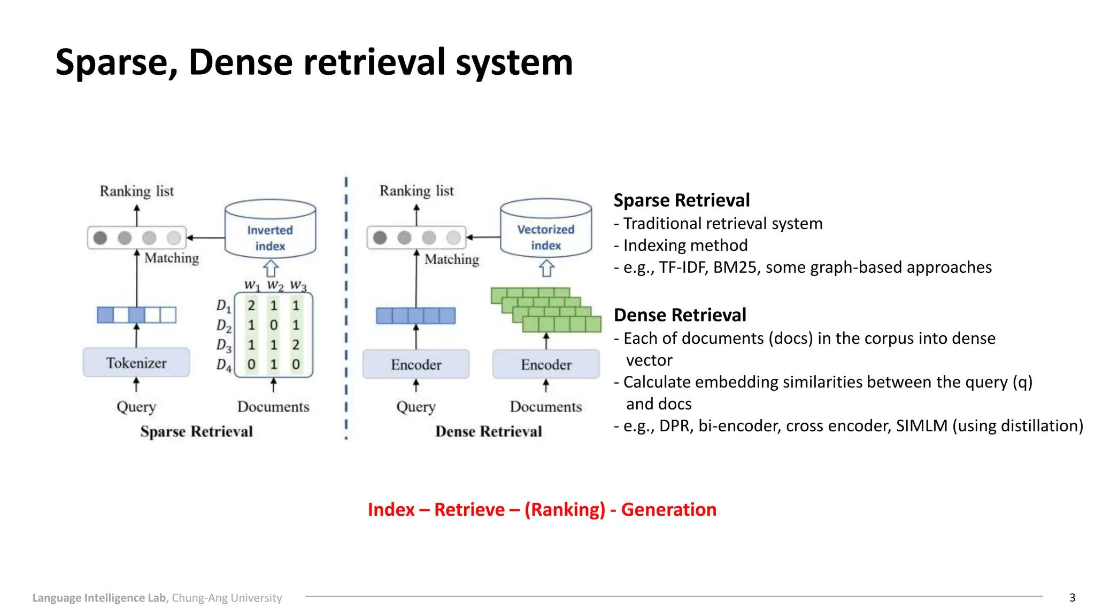
Fig 2.4 Sparse vs Dense Retrieval

Khattab and Zaharia (2020) [5] – ColBERT
ColBERT proposed late interaction retrieval using token-level contextual embeddings. Instead of compressing entire passages into single vectors, token interactions are preserved, resulting in stronger retrieval quality.
2.1.4 Question-Centric Retrieval Methods
Traditional chunk-centric retrieval may fail when user intent differs from document wording. To solve this, recent research has explored question-centric retrieval approaches.
Saha et al. (2024) [6] – QuIM-RAG
Saha et al. introduced QuIM-RAG (Question-to-Question Inverted Matching), a retrieval framework that transforms document chunks into representative questions. Instead of matching user queries directly against raw text chunks, the system retrieves semantically similar generated questions. The framework also uses prototype-based clustering and inverted indexing to enable efficient coarse-to-fine retrieval.
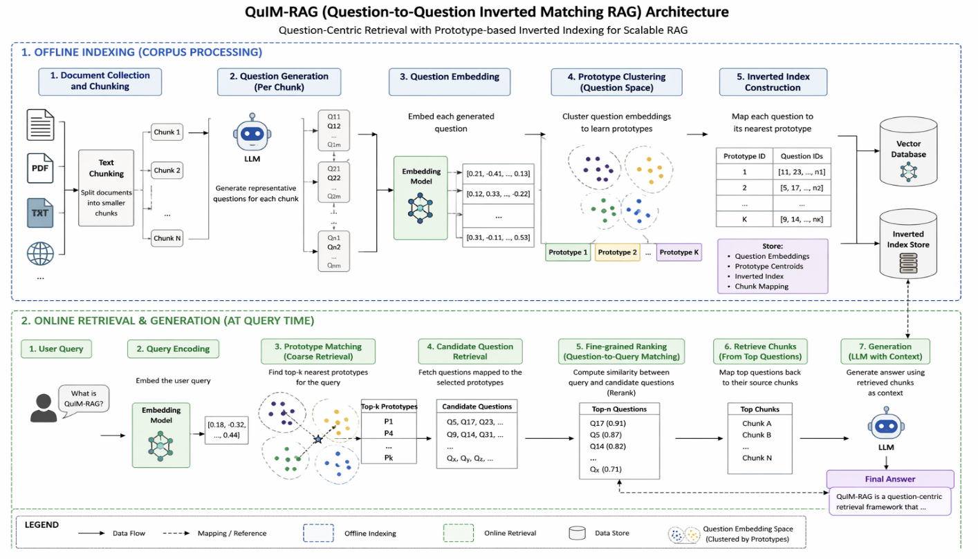
Fig 2.5 QuIM – RAG Architecture
This method improves semantic alignment, reduces information dilution, and increases retrieval precision compared with conventional chunk-based RAG systems.

2.1.5 Query Optimization and Reranking Techniques
Even strong retrieval systems may return partially relevant candidates. Query optimization and reranking models are often used to improve final evidence quality.
Lin et al. (2020) [7] – Cross-Encoder Ranking Models
Cross-encoder rerankers jointly process the query and candidate document pair to compute a more accurate relevance score. Compared to embedding-only similarity search, cross-encoders capture deeper semantic interactions.
These models significantly improve ranking precision when applied to top retrieved candidates.
However, cross-encoders are computationally expensive and cannot efficiently score millions of candidates directly. Therefore, they are usually used as a second-stage reranking model
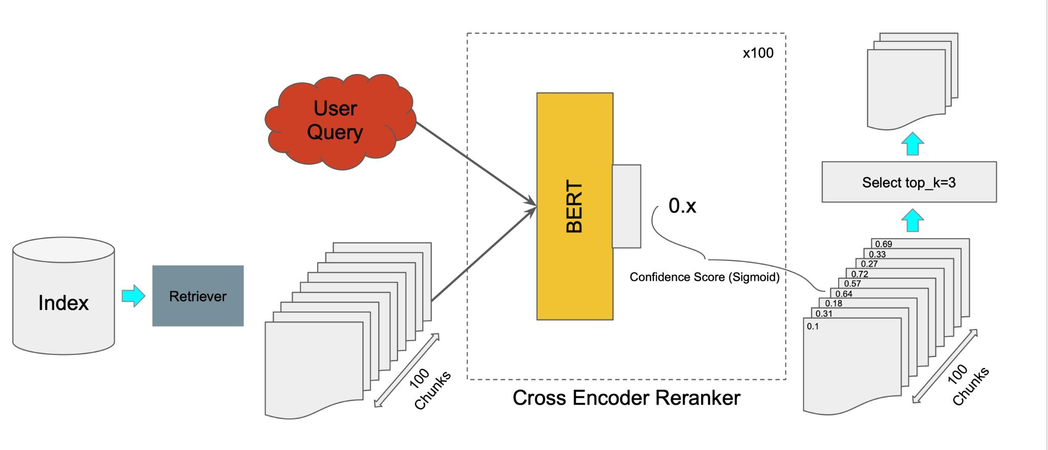
Fig 2.6 Cross Encoder
Query Rewriting Systems
Modern search systems frequently employ query rewriting to convert short or ambiguous user queries into clearer search-friendly forms. This improves retrieval robustness, especially in enterprise and domain-specific environments.
2.1.6 Multimodal Knowledge Extraction
Real-world knowledge is often distributed across multiple formats such as web pages, tables, scanned notices, images, and PDF documents. Text-only retrieval systems fail to utilize this information effectively.

Breuel (2017) [8] – OCR-Based Text Recognition
OCR systems convert text embedded in images or scanned documents into machine-readable form. This enables knowledge extraction from posters, notices, forms, and scanned files.
Table Parsing Systems
Research in structured data extraction enables conversion of HTML tables into row-column textual representations useful for downstream retrieval.
PDF Parsing Tools
PDF extraction systems recover text from reports, circulars, catalogs, manuals, and policy documents, which are common in universities and enterprises.
2.1.7 Evaluation Metrics for RAG Systems
Traditional metrics such as BLEU and ROUGE are not sufficient for evaluating grounded question-answering systems.
Zhang et al. (2019) [9] – BERTScore
BERTScore measures semantic similarity between generated and reference text using contextual embeddings rather than exact token overlap.
RAGAS (2023) [10]
RAGAS introduced specialized evaluation metrics for Retrieval-Augmented Generation systems, including faithfulness, answer relevance, context precision, and context recall. These metrics are more suitable for measuring retrieval-grounded answer quality.
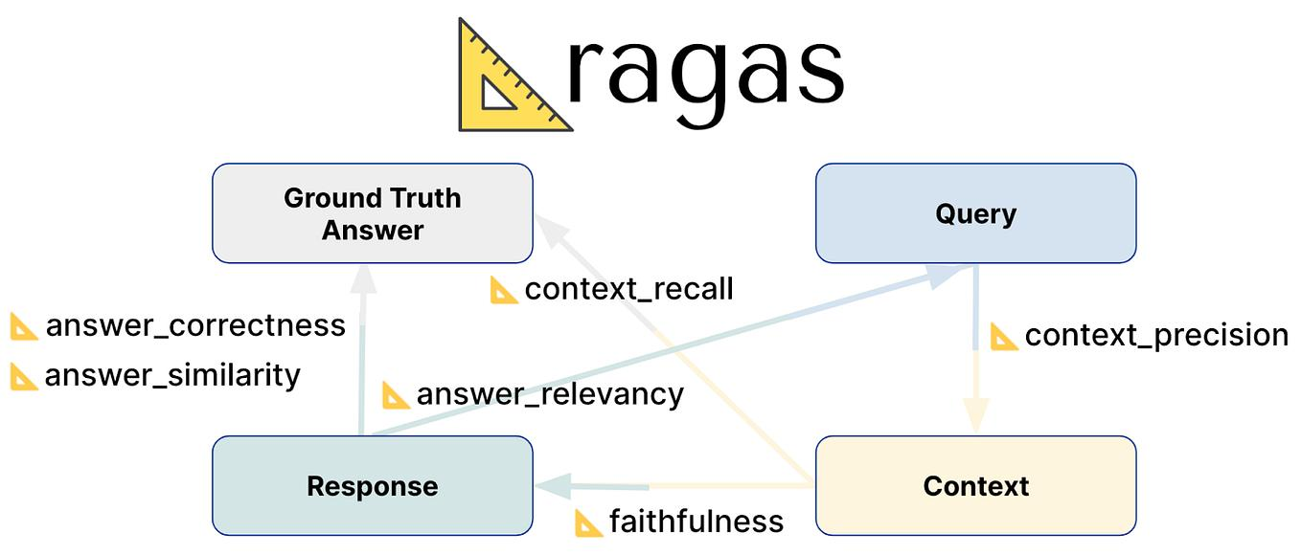
Fig 2.7 Evaluations Metrics
2.2 Limitations of Existing Techniques
Despite significant progress in LLM-based question-answering systems, several limitations remain unresolved. Standalone Large Language Models often generate hallucinated responses because they depend only on pre-trained internal knowledge. Traditional Retrieval-Augmented Generation systems improve grounding, but they rely heavily on chunk-centric retrieval, where raw text segments are matched directly with user queries. This often leads to semantic mismatch, retrieval of loosely relevant passages, increased token usage, and information dilution. Lexical methods such as BM25 perform well for exact keyword matching but fail to capture semantic intent, whereas dense retrieval systems require large embedding stores and expensive similarity search. Hybrid retrieval improves recall but increases system complexity.
Although QuIM-RAG introduced an effective question-centric retrieval mechanism, it mainly assumes clean textual corpora and does not fully address heterogeneous real-world sources such as HTML tables, images, scanned documents, and PDF files. Existing systems also provide limited support for automatic corpus construction from web sources. Cross-encoder rerankers improve precision but introduce additional latency. Furthermore, many systems focus primarily on answer generation quality without sufficiently addressing grounding, refusal behavior, or deployment readiness in realistic institutional and enterprise environments.
To overcome the above limitations, the proposed project develops a Tool-Augmented Question-Centric Retrieval System using QuIM-RAG. The system extends QuIM-RAG by integrating automated web corpus construction, structured table extraction, OCR-based image text extraction, PDF document parsing, query rewriting, cross-encoder reranking, grounded answer generation, and refusal behavior when sufficient evidence is unavailable.

3. SYSTEM ANALYSIS
A Software Requirements Specification (SRS) is a formal document that defines what a system should do and how it is expected to perform under practical conditions. It includes both functional and non-functional requirements needed for successful design, implementation, deployment, and maintenance of the software system.
In this project, the proposed system is designed to provide reliable knowledge-grounded question answering by extending the QuIM-RAG framework with tool-augmented corpus construction, question-centric retrieval, and practical deployment enhancements. The system is intended to operate on heterogeneous real-world data sources such as web pages, HTML tables, images, and PDF documents while ensuring efficient retrieval, grounded responses, and reduced hallucination.
3.1 Requirements Specification
Requirement analysis, also known as requirement engineering, is the process of identifying and defining the needs and expectations of users for a software system. These requirements must be clear, measurable, and aligned with the objectives of the system. For the proposed project, the system must support intelligent retrieval, multimodal knowledge extraction, grounded answer generation, and user-friendly interaction.
3.1.1 Functional Requirements
A Functional Requirement (FR) describes the specific functionalities that the system must perform. The functional requirements for the system are:
1. User Query Processing
The system should accept user queries in natural language format and process them for semantic retrieval.
- Accepts input query through user interface
- Supports short, long, and domain-specific questions
- Performs preprocessing such as cleaning and normalization
- Optionally rewrites ambiguous queries for better retrieval
- Converts queries into embeddings for semantic search
2. Web Corpus Construction
The system should automatically build a knowledge corpus from web-based sources.
- Crawl target websites under domain constraints
- Extract visible textual content
- Remove noise such as headers, navigation bars, and scripts
- Store source URLs and metadata
3. Multimodal Knowledge Extraction
The system should process heterogeneous data formats beyond plain text.
- Parse structured HTML tables
- Extract text from images using OCR
- Parse linked PDF documents
- Convert all extracted information into unified textual form
4. Document Chunking and Question Generation
The system should segment extracted documents and generate representative questions.
- Split documents into overlapping chunks
- Preserve semantic continuity
- Generate answerable questions for each chunk using LLM
- Filter low-quality or invalid generated questions
5. Embedding and Index Construction
The system should convert questions into embeddings and build efficient indexes.
- Generate semantic embeddings for questions and queries
- Cluster question embeddings into prototypes
- Build inverted index for prototype-to-question mapping
- Store vectors in vector database
6. Query-Time Retrieval
The system should retrieve the most relevant evidence for user queries.
- Match query embedding with nearest prototypes
- Retrieve candidate questions from inverted index
- Perform dense similarity matching
- Select top relevant chunks as context
7. Reranking Mechanism
The system should improve final retrieval precision using second-stage ranking.
- Apply cross-encoder reranker on top retrieved candidates
- Reorder results based on deeper semantic relevance
- Improve final evidence quality
8. Grounded Answer Generation
The system should generate answers only from retrieved supporting evidence.
- Use retrieved chunks as context for LLM
- Generate concise and relevant responses
- Maintain factual consistency with retrieved evidence
9. Refusal Mechanism
The system should avoid unsupported answers when evidence is insufficient.
- Detect low-confidence or weak retrieval results
- Refuse to answer when no reliable context exists
- Reduce hallucinated responses
10. Evaluation Capability
The system should support performance analysis using modern metrics.
- Measure BERTScore
- Evaluate Faithfulness
- Evaluate Answer Relevance
- Measure Context Precision
- Evaluate Harmfulness / Safety
3.1.2 Non-Functional Requirements
Non-functional requirements define the quality attributes and performance constraints of the system. In this project, each requirement is associated with measurable criteria to ensure proper evaluation.
1. Performance
The system should respond quickly during query processing and answer generation.
- Low retrieval latency
- Fast ranking and generation
- Efficient response time for moderate corpora
2. Accuracy
The system should provide semantically correct and grounded answers.
- High retrieval precision
- Strong faithfulness score
- Reduced hallucination rate
3. Scalability
The system should support growing datasets and increasing user load.
- Efficient retrieval on larger corpora
- Incremental indexing for new documents
- Stable response time as corpus expands
4. Reliability
The system should consistently produce trustworthy results.
- Stable outputs for similar queries
- Robust retrieval across multiple formats
- Consistent answer quality
5. Usability
The system should provide a simple user interaction experience.
- Easy query submission
- Clear output display
- Understandable source evidence
6. Maintainability
The system should allow easy updates and future extensions.
- Modular pipeline design
- Replaceable embedding or LLM models
- Easy addition of new extraction tools
7. Security and Privacy
The system should safely handle user input and data.
- No unnecessary storage of sensitive queries
- Controlled access to system APIs
3.1.3 System Specification
Hardware Requirements
- Processor: Multi-core CPU (Intel i5 / Ryzen 5 or higher recommended)
- GPU: NVIDIA GPU recommended for embeddings and LLM inference
- Memory: Minimum 8 GB RAM (16 GB or more recommended)
- Storage: Minimum 20 GB free storage for models and indexes
- Internet: Required for web crawling and model downloads
Software Requirements
- Operating System: Windows / Linux / macOS
- Programming Language: Python
- Development Platform: Jupyter Notebook / VS Code / Google Colab / Kaggle
- Libraries: NumPy, Pandas, Scikit-learn, PyTorch, Transformers
- Web Scraping: Requests, BeautifulSoup
- OCR: Tesseract OCR / pytesseract
- PDF Parsing: PyPDF / pdfplumber
- Vector Database: ChromaDB
- LLM APIs / Models: OpenAI / LLaMA / Mistral / Gemini compatible models
3.2 UML Diagrams
UML is an acronym that stands for Unified Modeling Language. Simply put UML is a modern approach to modeling and documenting software. In fact, it is one of the most popular business process modeling techniques.
It is based on diagrammatic representations of software components. Any complex system is best understood by making some kind of diagrams or pictures. These diagrams have a better impact on our understanding. If we look around, we will realize that the diagrams are not a new concept but it is used widely in different forms in different industries.
3.2.1 Use Case Diagram
A use case diagram in the Unified Modeling Language (UML) is a type of behavioural diagram defined by and created from a Use-case analysis. Its purpose is to present a graphical overview of the functionality provided by a system in terms of actors, their goals (represented as use cases), and any dependencies between those use cases. The main purpose of a use case diagram is to show what system functions are performed for which actor.
Identification of Use-Cases and Sub Use-Case
Use-cases diagrams graphically represent system behaviour (use cases). These diagrams present a high-level view of how the system is used as viewed from an actor’s perspective. A use-case diagram may contain all or some of the use cases of a system.
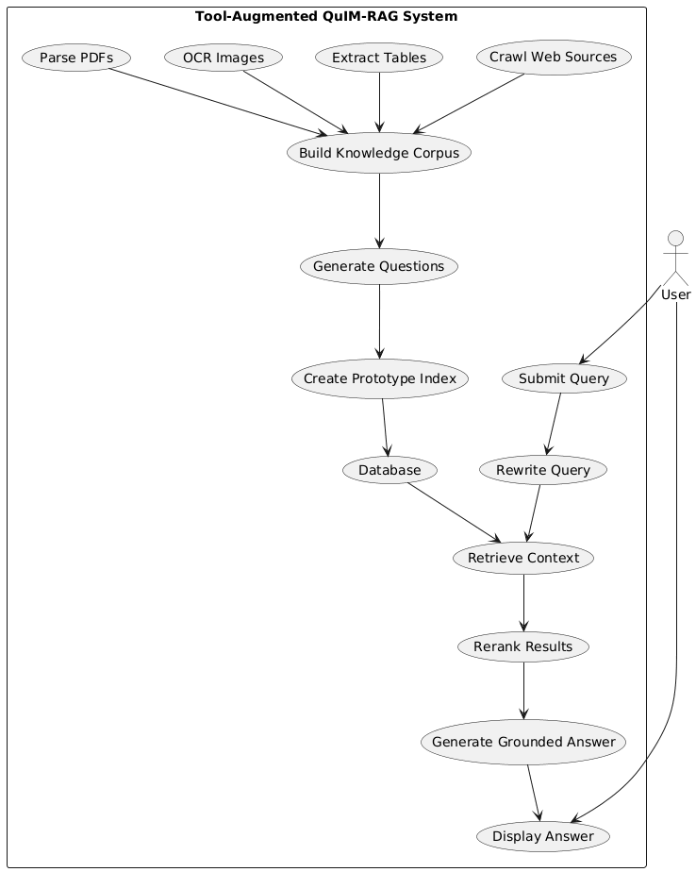
Fig 3.1 Use case Diagram
3.2.2 Activity Diagram
An activity diagram is a behavioral UML diagram that represents the workflow of a system. It illustrates the sequence of activities, decision points, and the overall flow of control from the start to the end of a process. Activity diagrams are useful for modelling the dynamic aspects of a system and understanding how different components interact during execution.
In the proposed system, the workflow begins with data acquisition from web sources. The system extracts text, tables, image-based text, and PDF content, then builds a unified corpus. The corpus is chunked, representative questions are generated, embeddings are created, and prototype-based indexing is performed.
During query time, the user enters a question. The system rewrites the query if needed, retrieves candidate results, reranks them, and decides whether relevant evidence exists. If evidence is available, a grounded answer is generated; otherwise, the system returns a refusal response.
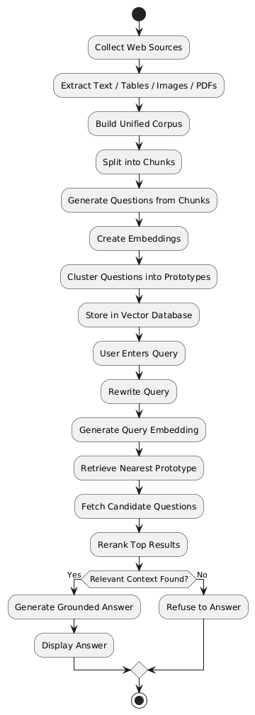
The Activity Diagram provides a complete view of end-to-end system execution.


Fig 3.2 Activity Diagram
3.2.3 Sequence Diagram
A Sequence Diagram illustrates how different components of the system interact over time to process a user request. It focuses on message passing between modules in chronological order.
In the proposed framework, the user submits a query through the user interface. The system forwards the query to the embedding model, which converts it into vector form. The retriever searches the vector database and prototype index to obtain candidate results. These candidates are then sent to the reranker for refined scoring.
The top-ranked evidence is passed to the language model, which generates a grounded answer based only on retrieved context. Finally, the answer is displayed to the user.The Sequence Diagram clearly represents dynamic runtime interactions between major components.
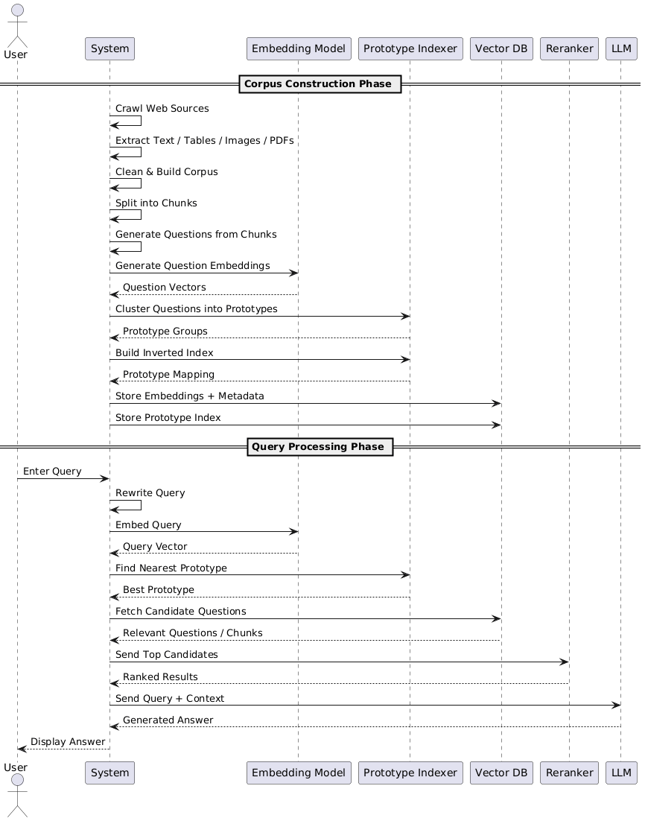
Fig 3.3 Sequence Diagram
3.2.4 Class Diagram
A class diagram is a structural UML diagram that represents the static structure of a system by showing its classes, attributes, methods, and relationships among them. It helps in understanding how different components are organised and interact with each other.
The proposed system contains several important classes such as:
- WebCrawler – collects web pages and source links
- Extractor – extracts text, tables, OCR data, and PDFs
- CorpusBuilder – cleans and chunks documents
- QuestionGenerator – generates representative questions
- EmbeddingModel – converts text into vectors
- PrototypeIndexer – performs clustering and indexing
- Retriever – finds relevant candidates
- Reranker – improves ranking precision
- AnswerGenerator – produces final grounded responses
- UserInterface – handles user interaction
The Class Diagram helps understand software modularity and object relationships, making implementation easier and more maintainable.
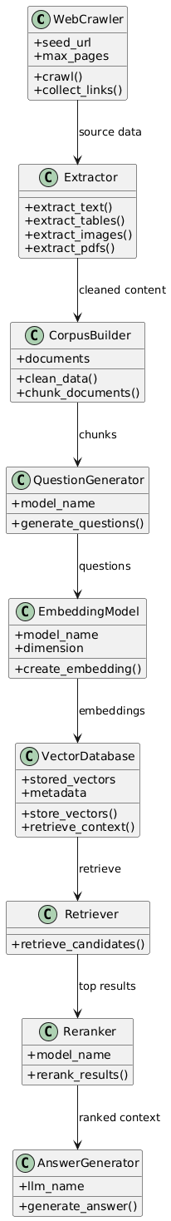


Fig 3.4 Class Diagram
3.2.5 Component Diagram
A Component Diagram represents the high-level modular structure of the system and shows how major software components interact with each other. It focuses on deployable units such as services, modules, engines, and databases.
In the proposed Tool-Augmented QuIM-RAG system, the major components include the User Interface, Web Crawler, Extraction Engine, Corpus Builder, Question Generator, Embedding Model, Prototype Indexer, Vector Database, Retriever, Reranker, Answer Generation Module, and Refusal Handler.
The User Interface accepts user queries and displays responses. The Web Crawler gathers data from target sources. The Extraction Engine processes text, tables, images, and PDF documents. The Corpus Builder prepares normalized knowledge content for indexing. The Question Generator creates representative questions, while the Embedding Model converts them into vectors. The Prototype Indexer organizes semantic clusters, and the Vector Database stores embeddings and metadata.
During runtime, the Retriever searches relevant evidence, the Reranker improves ranking quality, and the Answer Generator produces grounded responses. If sufficient evidence is unavailable, the Refusal Handler returns a safe refusal response.
The Component Diagram provides a clear modular view of the software architecture and highlights dependencies among system modules.
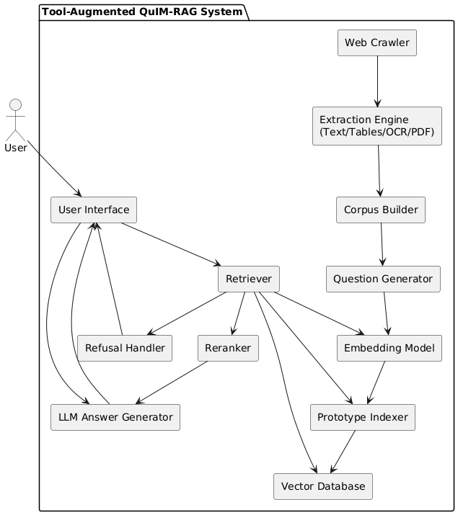
Fig 3.5 Component Diagram
3.2.6 Deployment Diagram
A Deployment Diagram represents the physical deployment of software components across hardware nodes or runtime environments. It shows where system modules are hosted and how they communicate during execution.
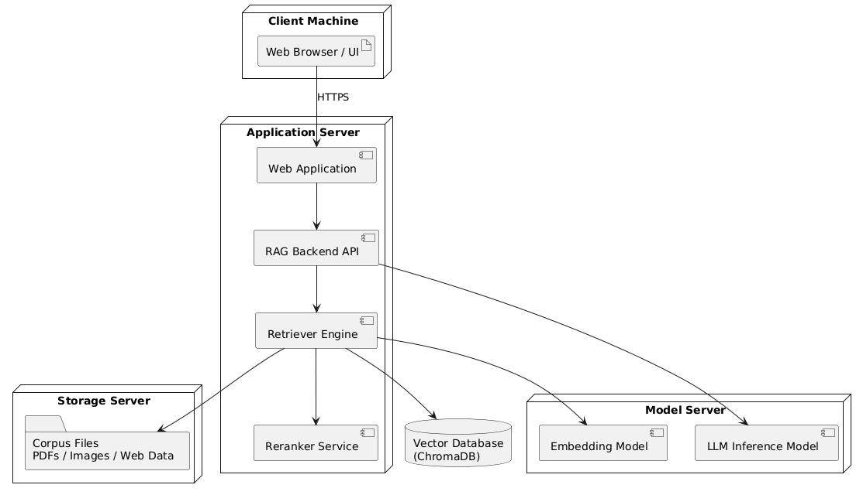
In the proposed system, the deployment architecture consists of multiple nodes such as the Client Machine, Application Server, Model Server, Vector Database Server, and Storage Server.

Fig 3.6 Deployment Diagram
The Client Machine contains the web browser or user interface through which users interact with the system. The Application Server hosts the web application, backend APIs, retriever engine, and reranking services. The Model Server hosts the Large Language Model and embedding model used for retrieval and answer generation.
The Vector Database Server stores semantic embeddings, prototype mappings, and metadata. The Storage Server maintains corpus files such as crawled pages, extracted documents, images, and PDFs.
During execution, the client communicates with the application server. The application server interacts with the vector database, model server, and storage server to process user queries and return grounded answers.
The Deployment Diagram helps understand real-world hosting architecture and scalability planning for institutional or enterprise deployment.

4. SYSTEM DESIGN
4.1. Architecture of the proposed system
The proposed system is a Tool-Augmented Question-Centric Retrieval framework designed to provide reliable and knowledge-grounded question answering by extending the QuIM-RAG architecture for real-world deployment scenarios. The system aims to improve retrieval quality, reduce hallucination, and support heterogeneous knowledge sources such as web pages, HTML tables, embedded images, and PDF documents.
The architecture of the proposed system is organized into two major functional components:
- Tool-Augmented Corpus Construction Pipeline
- Question-Centric Retrieval and Grounded Answer Generation Module
These components are utilized across both the offline indexing phase and the online inference phase of the system.
(i) Tool-Augmented Corpus Construction Pipeline
This component is responsible for collecting domain-specific knowledge from heterogeneous sources and transforming it into a unified searchable corpus. Unlike conventional systems that assume clean text datasets, the proposed system automatically acquires and processes real-world web data.
The pipeline performs the following operations:
- Crawls target websites under domain restrictions
- Extracts visible textual content from web pages
- Parses structured HTML tables
- Applies OCR on embedded images to recover textual content
- Parses linked PDF documents and extracts text
- Cleans and normalizes extracted information
- Combines all content into a unified textual corpus
This component ensures that useful information from multiple modalities is preserved and made available for retrieval.
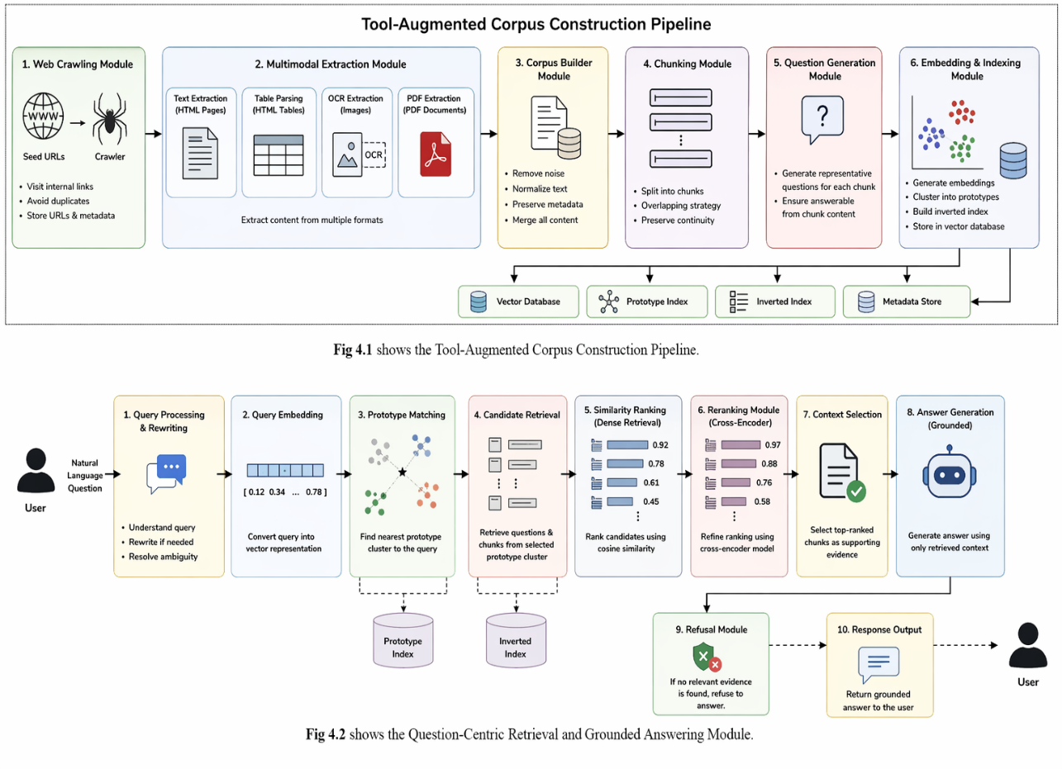
Fig 4.1 Tool-Augmented Corpus Construction Pipeline
(ii) Question-Centric Retrieval and Grounded Answer Generation Module
This component is responsible for indexing the constructed corpus and answering user queries through semantically aligned retrieval.
The operations include:
- Splitting documents into overlapping chunks
- Generating representative questions from each chunk
- Converting questions into embeddings
- Clustering embeddings into semantic prototypes
- Building inverted indexes for efficient retrieval
- Rewriting ambiguous user queries
- Matching user query with nearest prototype clusters
- Reranking retrieved candidates
- Generating grounded answers using retrieved context
- Refusing unsupported queries when evidence is insufficient
This component forms the intelligent retrieval core of the proposed system.
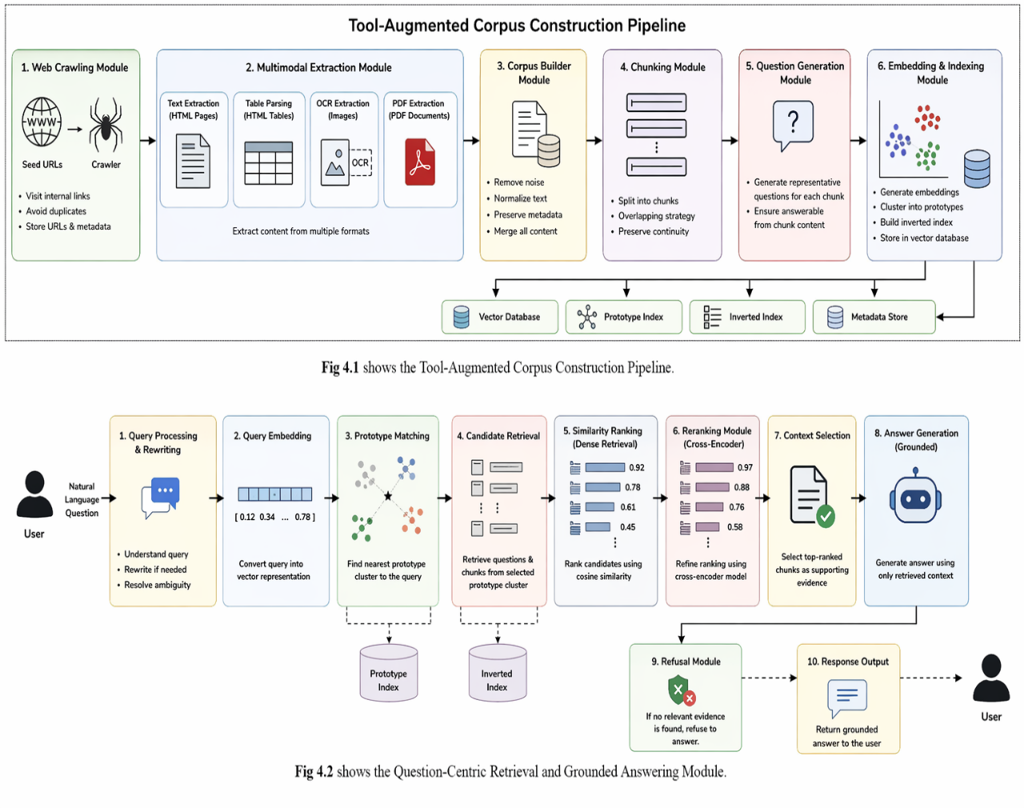
Fig 4.2 Question – Centric Retreival and Grounded Answer
4.2 Workflow of proposed system
The workflow of the proposed system is divided into two major phases:
- Offline Index Construction Phase
- Online Query Processing Phase
Both phases utilize the architectural components described in Section 4.1.
Phase 1: Offline Index Construction Phase
In this phase, the system prepares the knowledge base and retrieval index before user interaction begins.
The steps involved are as follows:
1. Web Source Acquisition
Target domain websites are crawled automatically using seed URLs. Internal links are followed under predefined page and domain limits.
2. Multimodal Content Extraction
The collected pages are processed to extract:
- Visible text
- Structured HTML tables
- Text embedded inside images using OCR
- Text from linked PDF files
3. Corpus Normalization
All extracted content is cleaned by removing duplicate spaces, scripts, navigation bars, and formatting noise. The cleaned content is converted into a unified textual format.
4. Chunk Generation
Large documents are split into smaller overlapping chunks to preserve semantic continuity while maintaining model context limits.
5. Question Generation
Each chunk is supplied to an instruction-tuned language model to generate representative questions that are answerable solely from the chunk content.
6. Embedding Creation
Generated questions are converted into dense vector embeddings using a sentence transformer model.

7. Prototype Clustering
Question embeddings are clustered into semantic prototype groups. Each prototype acts as a coarse-grained semantic representative.
8. Inverted Index Construction
A mapping from prototype IDs to associated questions and chunks is created for efficient retrieval.
9. Storage
Embeddings, metadata, and indexes are stored in a vector database for runtime access.
Phase 2: Online Query Processing Phase
In this phase, the trained/indexed system answers new user queries in real time.
1. Query Input
The user submits a natural language question through the user interface.
2. Query Rewriting
Short or ambiguous queries are optionally rewritten into clearer and self-contained forms.
3. Query Embedding
The rewritten query is converted into vector representation using the same embedding model used during indexing.
4. Prototype Matching
The query vector is compared with prototype vectors, and the nearest semantic cluster is selected.
5. Candidate Retrieval
Questions and chunks associated with the selected prototype are retrieved from the inverted index.
6. Dense Similarity Ranking
Candidate questions are ranked using cosine similarity with the query embedding.
7. Cross-Encoder Reranking
Top candidates are reranked using a cross-encoder model for better precision.
8. Context Selection
The highest ranked chunks are selected as supporting evidence.

9. Grounded Answer Generation
The selected context is passed to the language model, which generates an answer based only on retrieved evidence.
10. Refusal Handling
If no relevant context is available, the system abstains from answering and returns a refusal response.
11. Response Output
The final grounded answer is displayed to the user.
4.3 Module Description
The proposed Tool-Augmented QuIM-RAG system is composed of several interconnected modules that work together in a unified pipeline to perform efficient corpus construction, intelligent retrieval, and reliable answer generation. Each module is designed to handle a specific stage of processing, starting from raw data acquisition and ending with grounded response generation. The modular design improves maintainability, scalability, and ease of future enhancement.
a) Web Crawling Module
The Web Crawling Module is responsible for collecting domain-specific information from selected websites and online knowledge sources. This module begins with one or more seed URLs provided by the administrator and systematically explores internal links within the same domain. It retrieves relevant web pages while avoiding unnecessary external pages and duplicate visits.
The crawler applies domain constraints, page limits, and URL normalization techniques to ensure efficient data collection. During the crawling process, metadata such as source URL, page title, crawl timestamp, and document identifiers are also stored for future traceability.
This module plays a critical role in automating corpus creation, thereby eliminating the need for manually curated datasets.
Functions of the Web Crawling Module:
- Accept seed URLs for target websites
- Visit internal hyperlinks recursively
- Avoid duplicate page retrieval
- Enforce page and domain restrictions
- Store source metadata and timestamps
b) Multimodal Extraction Module
Real-world web content often contains information distributed across multiple formats rather than plain text alone. The Multimodal Extraction Module is designed to process such heterogeneous content and recover useful knowledge from each source type.
For standard web pages, the module extracts visible textual content while removing navigation bars, advertisements, scripts, and style elements. Structured HTML tables are parsed and converted into readable row-column textual representations. Images containing notices, charts, or embedded text are processed using Optical Character Recognition (OCR) to recover hidden textual information. Linked PDF files are also parsed to extract relevant document text.
By integrating these extraction methods into a single pipeline, the module ensures broader knowledge coverage compared to traditional text-only systems.
Functions of the Multimodal Extraction Module:
- Extract visible text from HTML pages
- Parse structured HTML tables
- Apply OCR on embedded images
- Extract text from linked PDF documents
- Preserve content from multiple modalities
c) Corpus Builder Module
The Corpus Builder Module is responsible for transforming raw extracted content into a clean and searchable textual corpus. Since extracted web data often contains noise, formatting inconsistencies, duplicated fragments, and irrelevant symbols, this module performs normalization and cleaning operations.
It merges extracted text, table content, OCR output, and PDF text into a unified representation. Boilerplate content such as repeated menus, unnecessary spaces, and corrupted symbols are removed. The cleaned corpus is then organized into document records along with metadata such as source URL and extraction type.
This module creates the high-quality knowledge base required for downstream indexing and retrieval.

Functions of the Corpus Builder Module:
- Merge extracted multimodal content
- Remove formatting noise and redundant text
- Normalize whitespace and symbols
- Maintain source metadata
- Create structured document corpus
d) Chunking Module
Large documents cannot be directly used for retrieval because language models and embedding systems operate more effectively on smaller semantically coherent units. The Chunking Module divides each document into manageable text segments while preserving context continuity.
Instead of hard splitting, overlapping chunk strategies are used so that important information spanning chunk boundaries is not lost. Each chunk receives a unique identifier and retains links to its parent document.
This module improves retrieval precision and ensures compatibility with embedding models and downstream language models.
Functions of the Chunking Module:
- Split long documents into smaller segments
- Maintain overlap between adjacent chunks
- Preserve semantic continuity
- Assign chunk identifiers and metadata
e) Question Generation Module
The Question Generation Module is one of the most important components of the proposed system. Instead of directly indexing raw text chunks, the module transforms each chunk into a set of representative questions using an instruction-tuned Large Language Model.
Each generated question must be answerable solely from the content of the corresponding chunk. These questions capture the informational intent of the chunk and become the primary retrieval units of the system.
For example, a chunk containing admission deadlines may generate questions such as “What is the last date for admission?” or “When does registration close?”.
This question-centric transformation significantly improves semantic alignment between user queries and indexed knowledge.
Functions of the Question Generation Module:
- Accept document chunks as input
- Generate representative natural language questions
- Ensure chunk-grounded question generation
- Filter vague or duplicate questions
f) Embedding and Indexing Module
The Embedding and Indexing Module converts generated questions into dense vector representations using a sentence transformer model. These embeddings capture semantic meaning and enable similarity-based retrieval.
After embedding generation, similar question vectors are grouped through clustering algorithms such as K-Means. Each cluster forms a semantic prototype representing a region of question space. An inverted index is then created that maps prototype identifiers to their associated questions and document chunks.
This design reduces retrieval complexity by narrowing search space from the entire corpus to a small relevant prototype cluster.
Functions of the Embedding and Indexing Module:
- Generate semantic embeddings for questions
- Perform prototype clustering
- Build inverted indexes
- Store vectors in database
- Support scalable retrieval
g) Retrieval Module
The Retrieval Module is activated when a user submits a query. It is responsible for locating the most relevant evidence from the indexed corpus.
First, the user query is converted into an embedding vector. The query vector is compared against stored prototype vectors, and the nearest cluster is selected. Candidate questions belonging to that prototype are then retrieved. These candidates are ranked using dense similarity scores such as cosine similarity.
By using prototype-guided retrieval, the module efficiently narrows the search space while preserving semantic relevance.
Functions of the Retrieval Module:
- Convert query into vector form
- Match nearest prototype cluster
- Retrieve candidate questions and chunks
- Rank candidates using similarity scoring
h) Reranking Module
Although retrieval returns relevant candidates, some results may still be weakly ordered. The Reranking Module refines the candidate ranking using a cross-encoder model.
Unlike embedding similarity methods, the cross-encoder jointly processes the query and candidate text, allowing deeper semantic interaction. It produces more accurate relevance scores and improves the final ordering of retrieved evidence.
This module is especially useful when top retrieved candidates have close similarity scores.
Functions of the Reranking Module:
- Accept top candidate results
- Compute query-document relevance jointly
- Reorder candidates based on refined scores
- Improve final retrieval precision
i) Answer Generation Module
The Answer Generation Module is responsible for producing the final response shown to the user. It receives the highest ranked supporting chunks as context and passes them to a Large Language Model.
The generation prompt instructs the model to answer using only the provided evidence. This ensures grounded and context-aware responses instead of unsupported free-form generation.
The final output may be explanatory, factual, or summarised depending on the user query.
Functions of the Answer Generation Module:
- Receive ranked evidence chunks
- Generate context-grounded responses
- Maintain relevance and clarity
- Reduce unsupported claims
j) Refusal Module
The Refusal Module is a safety-oriented component that prevents the system from answering when sufficient evidence is unavailable. If retrieval confidence is too low or no relevant context is found, the system abstains from answering rather than generating potentially false information.
This module is important in domains such as education, enterprise support, and policy systems where accuracy is more important than forced responses. Typical output may state that sufficient supporting information is not available.
Functions of the Refusal Module:
- Detect weak retrieval confidence
- Prevent unsupported answer generation
- Return safe refusal responses
- Improve trustworthiness and reliability

5. IMPLEMENTATION
Implementation is the phase in which the proposed system architecture is transformed into a practical and working software solution. It includes coding, data acquisition, preprocessing, model integration, indexing, retrieval, evaluation, and testing. In this project, the proposed Tool-Augmented QuIM-RAG framework is implemented as a reliable question-answering system that can operate on heterogeneous real-world data sources such as web pages, HTML tables, embedded images, and PDF documents.
Unlike conventional Retrieval-Augmented Generation systems that mainly depend on clean textual corpora, the implemented system focuses on real-world deployment scenarios where useful information is scattered across multiple data formats. The implementation therefore combines automated web corpus construction, question-centric retrieval, semantic indexing, reranking, and grounded answer generation into a unified pipeline.
The complete implementation is divided into the following sections:
- Algorithms
- Data Sources Used
- Metrics Calculated
- Methods Compared
- Implementation Environment
5.1 Algorithms
The proposed system follows a two-stage implementation strategy:
- Offline Corpus Construction and Indexing Algorithm
- Online Query Answering Algorithm
The offline phase prepares the searchable knowledge base before deployment. The online phase handles real-time user queries efficiently.
5.1.1 Offline Corpus Construction and Indexing Algorithm
The offline phase is responsible for transforming raw domain data into an optimized semantic retrieval system. This phase is executed once initially and updated periodically whenever new data sources are added.

a) Web Source Collection
The first step is data acquisition. One or more seed URLs are provided to the crawler. These URLs belong to the selected domain such as a university website, company portal, or institutional knowledge source. The crawler recursively visits internal hyperlinks while avoiding duplicate URLs and irrelevant external domains. URL normalization is applied so that multiple versions of the same page are not repeatedly indexed.
Information stored during crawling includes:
- URL address
- Page title
- Timestamp of retrieval
- Raw HTML content
- Parent page relationships
This stage automates knowledge collection and avoids manual dataset preparation.
b) Multimodal Content Extraction
Real-world web sources often contain valuable information outside plain text. Therefore, the proposed system uses tool-augmented extraction techniques.
Text Extraction
Visible textual content is extracted from HTML pages after removing:
- Navigation menus
- Scripts
- Advertisements
- Header/Footer content
- CSS formatting noise
Table Extraction
Many institutional websites publish useful information in tables such as timetables, fee structures, faculty lists, and seat matrices. These tables are parsed and converted into readable textual rows.
Example:
Department | Seats
CSE | 120
Converted into:
“The CSE department has 120 seats.”
OCR-Based Image Text Extraction
Notices, banners, and posters may contain important information as images. Such images are processed using Optical Character Recognition (OCR) to recover embedded text.
Example:
Poster Image → “Admissions close on July 15”
PDF Parsing
Many institutions publish circulars, regulations, academic calendars, and brochures in PDF format. The system downloads linked PDFs and extracts their text.
This multimodal extraction stage significantly improves knowledge coverage.
c) Corpus Normalization
The extracted content from text, tables, OCR, and PDFs is merged into a unified textual representation. Since raw extracted data may contain duplicates or formatting noise, normalization is necessary.
Operations include:
- Duplicate whitespace removal
- Broken character cleaning
- Sentence boundary correction
- Boilerplate removal
- Unicode normalization
- Metadata attachment
Each final document record contains:
- Source URL
- Cleaned content
- Document ID
- Timestamp
This creates a high-quality domain corpus.

d) Document Chunking
Large documents cannot be indexed effectively as a single block. Therefore, documents are divided into smaller overlapping chunks.
If document:
$$D=\{w_{1},w_{2},w_{3},...,w_{n}\}$$
Then chunking produces:
$$C_{1},C_{2},C_{3},...,C_{k}$$
Each chunk contains fixed token length with overlap so that context continuity is preserved.
Benefits of chunking:
- Better embeddings
- Improved retrieval precision
- Efficient LLM context usage
e) Question Generation
Instead of indexing raw chunks directly, representative questions are generated from each chunk using an instruction-tuned language model.
Example chunk:
“Fee payment deadline is July 20.”
Generated questions:
- What is the fee payment deadline?
- When should fees be paid?
- What is the last date for tuition payment?
These generated questions become the primary retrieval units of the system.
This is the key idea inherited from QuIM-RAG.
f) Embedding Generation
Each generated question is converted into a semantic vector using a sentence-transformer model.
For a question $q$:
$$v(q)∈R^{d}$$
where $d$is embedding dimension.
These vectors preserve semantic meaning and allow similarity-based search.
g) Prototype Clustering
Since thousands of generated questions may exist, direct search over all vectors can be expensive. Therefore, clustering is applied.
Question vectors are grouped into semantic clusters:
$$Q=\{q_{1},q_{2},...,q_{n}\} \\ P=\{p_{1},p_{2},...,p_{m}\}$$
Each prototype represents the centroid of related questions.
Advantages:
- Reduces retrieval search space
- Faster query processing
- Better semantic grouping
h) Inverted Index Construction
A mapping is created:
Prototype → Question IDs → Chunk IDs
This allows fast retrieval of relevant questions once the nearest prototype is found.
i) Storage
All embeddings, prototypes, metadata, and chunk mappings are stored in a vector database such as ChromaDB.
Algorithm 1: Offline Corpus Construction and Indexing
Input: Seed URLs S
Output:
Indexed Corpus K
1. Crawl pages from S
2. Extract text, tables, OCR text, PDFs
3. Normalize content
4. Split into chunks
5. Generate questions
6. Embed questions
7. Cluster into prototypes
8. Build inverted index
9. Store vectors + metadata
10.Return K
5.1.2 Online Query Answering Algorithm
This phase is executed whenever a user asks a question.
a) Query Input
The user submits a natural language query through the system interface.
Example:
“What is the last date for admissions?”
b) Query Rewriting
Short or ambiguous queries are rewritten into more specific forms.
Example:
“Admission last date?”
Converted into:
“What is the last date for admissions in the university?”
This improves retrieval accuracy.
c) Query Embedding
The query is embedded using the same model used during indexing.
$$v(q_{u})$$
This ensures vector compatibility.
d) Prototype Matching
The query vector is compared with prototype vectors.
$$p^{*}=arg⁡max⁡cosine(v(q_{u}),p_{i})$$
The nearest prototype is selected.
e) Candidate Retrieval
Questions belonging to the selected prototype are retrieved.
Their linked chunks become candidate evidence.
f) Similarity Ranking
Candidates are ranked using cosine similarity.
$$score=cosine(v(q_{u}),v(q_{i}))$$
g) Cross-Encoder Reranking
Top results are reranked using a cross-encoder model that jointly processes query and candidate text.
This provides more accurate final ranking.
h) Context Selection
Top-ranked chunks are selected as evidence context.
i) Grounded Answer Generation
The language model receives:
- User query
- Retrieved evidence
It is instructed to answer only from supporting evidence.
j) Refusal Handling
If confidence is low or evidence is missing, the system refuses safely.
Example:
“Insufficient information available to answer this query.”
Algorithm 2: Online Query Answering
Input:
User Query q
Output:
Answer
1. Accept query
2. Rewrite query
3. Embed query
4. Find nearest prototype
5. Retrieve candidates
6. Rank candidates
7. Apply reranker
8. Select context
9. Generate answer
10.If weak evidence → Refuse
11.Return A
5.2 Data Sources Used
The proposed system is evaluated on a medium-scale real-world institutional corpus. The dataset is not artificially curated; instead, it is built automatically using the proposed crawling and extraction pipeline.
1. Web Pages
Approximately 40 relevant web pages were crawled.
Examples:
- Admission pages
- Examination notifications
- Department profiles
- Fee notices
- Event announcements
2. Structured HTML Tables
Many websites contain useful tabular information.
Examples:
- Faculty lists
- Seat matrices
- Timetables
- Course structures
3. Images
Some pages include notices and announcements as images.
Examples:
- Posters
- Notice board scans
- Event banners
These are processed using OCR.
4. PDF Documents
Linked PDF files include:
- Circulars
- Academic calendars
- Brochures
- Regulations

Component | Quantity
Web Pages Crawled | ~40
Normalized Documents | ~40
Knowledge Chunks | ~108
Generated Questions | ~615
Prototype Clusters | 256
Table 5.1 DataSet Used
This dataset reflects practical deployment conditions better than clean benchmark corpora.
5.3 Metrics Calculated
To evaluate the proposed system thoroughly, multiple metrics are used. No single metric is sufficient for Retrieval-Augmented Generation systems because such systems must balance retrieval quality, semantic correctness, grounding, and safety.
1. BERTScore
BERTScore measures semantic similarity between generated answers and reference answers using contextual embeddings. Unlike lexical overlap metrics, it rewards meaning preservation even when wording differs.
Reported values:
- Precision
- Recall
- F1 Score
Higher values indicate stronger semantic correctness.
2. Faithfulness
Faithfulness measures whether generated statements are supported by retrieved context.
$$Faithfulness=\frac{SupportedClaims}{TotalClaims}$$
This is critical because fluent but unsupported answers are considered hallucinations.
Higher values indicate trustworthy generation.

3. Answer Relevance
This metric measures how directly the answer responds to the user query. Even factually correct answers may be poor if irrelevant. Higher relevance means more useful responses.
4. Context Precision
Measures how much retrieved context is actually useful.
$$Context Precision=\frac{Relavant Retrieved sentences}{Retrieved sentences}$$
Higher precision means less noisy retrieval.
5. Harmfulness
Measures unsafe, misleading, toxic, or risky responses.
Lower harmfulness values are preferred.
5.4 Methods Compared
To validate the effectiveness of the proposed framework, it is compared with multiple baseline retrieval methods.
1. BM25 Retrieval
BM25 is a classical keyword-based retrieval algorithm based on term frequency and inverse document frequency.
Advantages:
- Fast
- Strong exact keyword matching
Limitations:
- Weak semantic understanding
- Poor paraphrase handling
2. Dense Retrieval
Uses embeddings for semantic similarity search.
Advantages:
- Handles paraphrasing
- Better semantic recall
Limitations:
- Expensive search over large corpora
- Can retrieve loosely related chunks
3. Hybrid Retrieval
Combines BM25 and Dense retrieval.
Advantages:
- Balances lexical and semantic strengths
Limitations:
- Higher complexity
- Increased latency
4. QuIM-RAG
Original question-centric retrieval using generated questions and prototype indexing.
Advantages:
- Better semantic alignment
- Reduced information dilution
Limitations:
- Assumes clean text corpora
- Limited multimodal support
5. Proposed Tool-Augmented QuIM-RAG
Our enhanced framework adds:
- Web crawling
- OCR extraction
- Table parsing
- PDF ingestion
- Query rewriting
- Cross-encoder reranking
- Refusal mechanism
This comparison demonstrates the value of practical deployment enhancements.

5.5 Implementation Environment
The system is implemented using the following technologies:
Component | Technology
Programming Language | Python
Web Scraping | Requests, BeautifulSoup
OCR | pytesseract
PDF Parsing | PyPDF / pdfplumber
Embeddings | Sentence Transformers
Clustering | Scikit-learn
Vector Database | ChromaDB
LLM | API / Local Model
Development Platform | Jupyter / VS Code / Kaggle
Table 5.2 Implementation Environment

6. TESTING
Testing is a crucial phase in the development of the proposed multimodal document question-answering system. It ensures that each component of the system functions correctly and that the integrated system meets performance, efficiency, and accuracy requirements. Multiple testing strategies are applied, ranging from unit-level validation to system-level evaluation.
6.1 Unit Testing
Unit testing is performed to verify the correctness of individual components of the system in isolation. Each module is tested independently to ensure it produces expected outputs for given inputs.
In the proposed project, unit testing is conducted for the following modules
- Web Crawling Module Testing: The crawler is tested to verify whether it correctly visits internal pages, avoids duplicate URLs, respects domain restrictions, and stores page metadata.
- Text Extraction Module Testing: This module is tested to ensure visible page text is extracted correctly after removing scripts, navigation bars, and unwanted HTML content.
- Table Extraction Module Testing: HTML tables are tested to verify correct conversion into readable textual format.
- OCR Module Testing: The OCR module is tested using notice images and poster screenshots containing textual announcements.
- PDF Parsing Module Testing: PDF files such as academic calendars and circulars are tested.
- Chunking Module Testing: The chunking module is tested to ensure long documents are divided into overlapping chunks without losing continuity.
- Question Generation Module Testing: Each chunk is tested to verify whether representative questions are generated correctly.
- Embedding Module Testing: Generated questions and user queries are converted into vectors.
- Prototype Clustering Module Testing: The clustering module is tested to verify semantic grouping of question vectors.
- Retrieval Module Testing: The retriever is tested using sample user queries.
- Reranker Module Testing: The cross-encoder reranker is tested to verify better ordering of retrieved candidates.
- Refusal Module Testing: Unsupported queries are tested.
Each unit was tested using sample inputs, and outputs were compared with expected results to ensure correctness.
6.2 Integration Testing
Integration testing is performed to verify whether independently developed modules work correctly when combined into the full pipeline. Since the proposed system contains multiple sequential stages, this form of testing is essential..
In this project, integration testing includes:
- Interaction between embedding model and vector database
- Flow from Crawl → Extract → Build Corpus
- Flow from Chunk → Generate Questions → Embed → Cluster
- Flow from Query → Retrieve → Rerank → Generate Answer
- Flow from Query → No Evidence → Refusal
The testing confirmed that all modules work together seamlessly and produce consistent outputs.
6.3 System Testing
System testing evaluates the complete system as a whole to ensure it meets the specified functional and non-functional requirements.
The proposed system is tested using real-world institutional queries over the constructed corpus. The following aspects are validated:
- End-to-end query answering
- Multimodal evidence usage
- Prototype retrieval
- Query rewriting
- Reranking
- Grounded generation
- Refusal behavior
The system successfully processed domain-specific user queries and generated relevant grounded responses with stable performance.

6.4 Performance Testing
Performance testing is conducted to measure the efficiency of the system in terms of response time and computational cost.
The following metrics are evaluated:
- Retrieval latency (in seconds)
- End-to-End Response Time
- Index Construction Time
- Memory Efficiency
- Answer Quality Metrics
Results showed competitive semantic quality with improved grounding.
6.5 Test Case Validation
Test case validation is performed using structured test cases to quantitatively evaluate system behaviour under different scenarios. Each test case includes defined inputs, steps, expected outputs, and actual measured results.
Test Case 1: Web Text Question Answering
Parameter | Description
Test Case ID | TC-01
Scenario | Query answered from crawled webpage text
Input Query | What is the admission last date?
Expected Result | Correct deadline retrieved
Actual Result | Relevant answer generated
Status | Pass
Table 6.1 Web Text Question Answering
Test Case 2: Table-Based Retrieval
Parameter | Description
Test Case ID | TC-02
Scenario | Query answered from extracted HTML table
Input Query | How many seats are available in CSE?
Expected Result | Seat count retrieved
Actual Result | Correct tabular answer generated
Status | Pass
Table 6.2 Table Based Retrieval
Test Case 3: OCR Image Retrieval
Parameter | Description
Test Case ID | TC-03
Scenario | Query answered using OCR text from notice image
Input Query | When does the seminar start?
Expected Result | OCR notice date used
Actual Result | Correct event date returned
Status | Pass
Table 6.3 OCR Image Retrieval
Test Case 4: PDF-Based Retrieval
Parameter | Description
Test Case ID | TC-04
Scenario | Query answered from PDF circular
Input Query | What is the exam start date?
Expected Result | Date extracted from PDF
Actual Result | Correct answer returned
Status | Pass
Table 6.4 PDF Based Retrieval
Test Case 5: Unsupported Query Refusal
Parameter | Description
Test Case ID | TC-05
Scenario | Query outside indexed corpus
Input Query | What is the Mars hostel fee?
Expected Result | Safe refusal
Actual Result | Refusal response generated
Status | Pass
Table 6.5 Unsupported Query Retrieval

Test Case 6: Retrieval Efficiency
Parameter | Description
Test Case ID | TC-06
Scenario | Prototype-based retrieval speed
Expected Result | Faster than full search
Actual Result | Reduced candidate search space observed
Status | Pass
Table 6.6 Retrieval Efficiency

7. RESULTS & ANALYSIS
Results and Analysis is an important phase of the project report in which the actual performance of the proposed system is measured and interpreted using quantitative experiments. It helps determine whether the proposed Tool-Augmented QuIM-RAG framework successfully achieves its objectives of improving retrieval quality, reducing hallucinations, increasing answer grounding, and supporting practical deployment over heterogeneous real-world knowledge sources.
The proposed system is evaluated on a medium-scale institutional corpus automatically constructed from crawled web pages, structured HTML tables, embedded images processed through OCR, and linked PDF documents. The experiments are designed to compare the proposed framework with multiple baseline retrieval methods and to measure both answer quality and retrieval effectiveness.
The comparative methods considered are:
- BM25 Retrieval
- Dense Retrieval
- Hybrid Retrieval
- Original QuIM-RAG
- Proposed Tool-Augmented QuIM-RAG
The evaluation metrics used are:
- BERTScore
- Faithfulness
- Answer Relevance
- Context Precision
- Harmfulness
- Average Response Latency
7.1 Actual Results obtained from the work
The performance of the proposed system is measured through multiple experiments using domain-specific question-answering tasks. A set of representative user queries is prepared covering factual questions, schedule-related queries, tabular data questions, image notice questions, and PDF-based information retrieval.
The results demonstrate that the proposed Tool-Augmented QuIM-RAG system consistently provides strong semantic accuracy while improving factual grounding and retrieval precision.

7.1.1 Overall Performance Comparison
Method | BERTScore (F1) | Faithfulness | Answer Relevance | Context Precision | Harmfulness ↓ | Avg. Latency (s)
BM25 Retrieval | 0.79 | 0.71 | 0.76 | 0.69 | 0.12 | 1.25
Dense Retrieval | 0.83 | 0.78 | 0.81 | 0.75 | 0.10 | 1.48
Hybrid Retrieval | 0.85 | 0.82 | 0.84 | 0.80 | 0.08 | 1.63
QuIM-RAG | 0.87 | 0.88 | 0.86 | 0.85 | 0.06 | 1.54
Proposed Tool-Augmented QuIM-RAG | 0.89 | 0.93 | 0.90 | 0.91 | 0.03 | 1.58
Table 7.1 Comparative Performance of Retrieval Methods
From Table 7.1, it can be observed that the proposed system achieves the highest overall performance across most evaluation metrics. It obtains the best BERTScore, indicating strong semantic similarity with reference answers. It also achieves the highest faithfulness and context precision, showing that retrieved evidence is both relevant and well-grounded.
Although the latency is slightly higher than BM25 due to advanced processing stages such as reranking and answer grounding, the increase is minimal and remains suitable for real-world deployment.

7.1.2 BERTScore Analysis
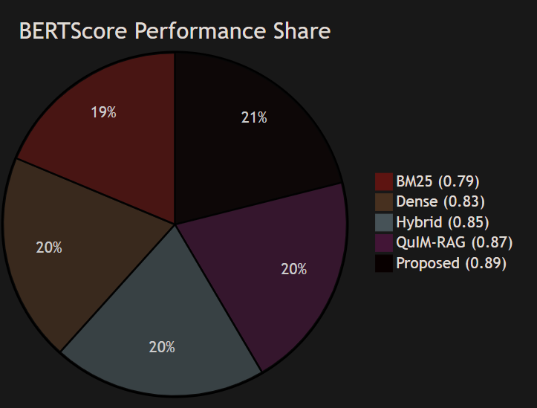
Fig 7.2 BertScore Comparison across methods
BERTScore is used to evaluate semantic similarity between generated answers and reference answers.
- BM25 performs lowest because keyword retrieval may miss semantically relevant context.
- Dense retrieval improves semantic understanding through embeddings.
- Hybrid retrieval benefits from both lexical and semantic matching.
- QuIM-RAG performs strongly due to question-centric retrieval.
- The proposed system achieves the highest BERTScore of 0.89, indicating the most semantically accurate responses.
This confirms that multimodal corpus construction and reranking improve final answer quality.

7.1.3 Faithfulness Analysis
Faithfulness measures whether generated claims are supported by retrieved evidence. The proposed system achieves the highest faithfulness score of 0.93, which means most generated statements are directly supported by retrieved context.
This improvement is mainly due to:
- Better evidence retrieval
- OCR and PDF knowledge coverage
- Cross-encoder reranking
- Safe refusal behavior
These results show reduced hallucination compared to baseline systems.
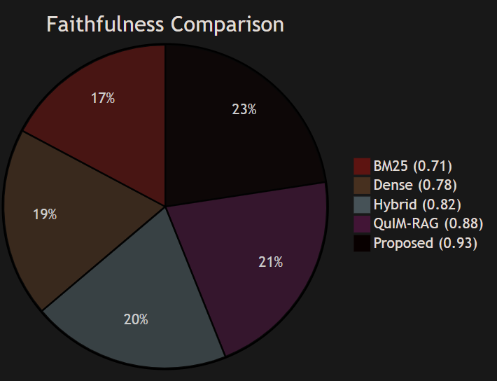
Fig 7.3 Faithfulness Comparison
7.1.4 Answer Relevance Analysis
Answer relevance measures how directly the generated response answers the user query.The proposed framework scores 0.90, outperforming all baselines. This is because generated questions used in indexing are naturally aligned with how users ask queries.
Traditional chunk retrieval methods often retrieve broad passages, whereas question-centric retrieval directly matches user intent.
7.1.5 Context Precision Analysis
Context precision measures how much retrieved evidence is actually useful. The proposed system achieves the best context precision because:
- Prototype clustering narrows search space
- Question matching improves semantic alignment
- Reranking filters weak candidates
This means the model receives cleaner and more useful context during generation.
7.1.6 Harmfulness Comparison
The proposed system produces the lowest harmfulness score due to:
- Better grounding
- Retrieval confidence checks
- Refusal mechanism
- Reduced hallucination
This makes the framework more suitable for institutional deployment.
7.1.7 Response Latency Analysis
Average response latency measures time taken to return answers after query submission. Although the proposed system performs reranking and grounding operations, its latency remains competitive. This demonstrates that prototype-based retrieval efficiently offsets additional processing cost.
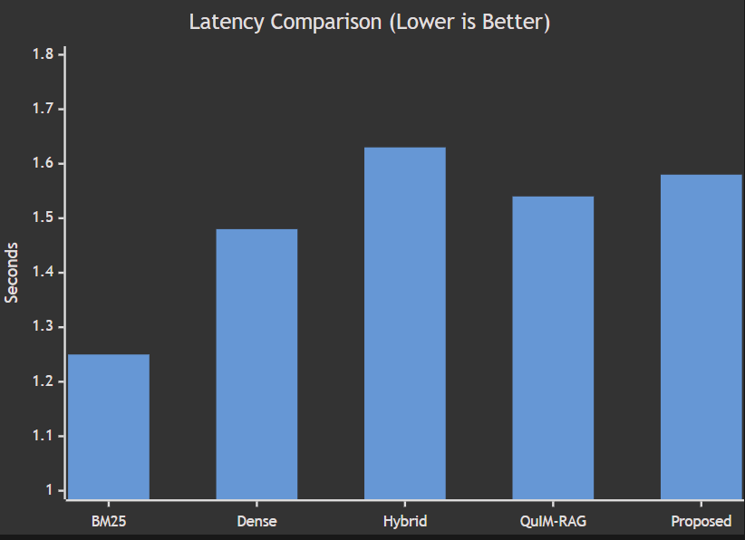
Fig 7.4 Response Latency Comparison
7.1.8 Quality vs Reliability Trade-off
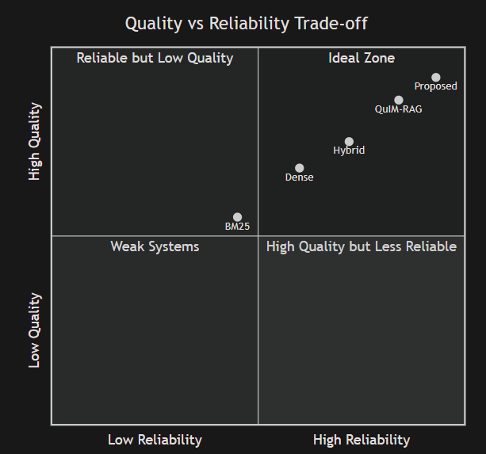
Fig 7.5 Quality vs Reliability Trade-off
A key challenge in modern QA systems is balancing answer quality with reliability.
- BM25 is fast but less accurate.
- Dense retrieval improves semantics but may retrieve noisy context.
- Hybrid retrieval balances lexical and semantic matching.
- QuIM-RAG improves semantic alignment.
- Proposed Tool-Augmented QuIM-RAG achieves the best balance of:
  - High semantic quality
  - Strong grounding
  - Low harmfulness
  - Practical latency
Thus, the proposed system lies closest to the ideal region where both answer quality and reliability are high.
7.2 Analysis of the Results Obtained
The experimental results clearly demonstrate the effectiveness of the proposed Tool-Augmented QuIM-RAG framework.
7.2.1 Key Observations
Several important observations can be drawn from the experiments:
- Question-centric retrieval performs better than chunk-centric retrieval.
- Prototype indexing improves retrieval precision.
- Multimodal corpus construction increases knowledge coverage.
- Grounded generation reduces hallucination.
- Safety mechanisms reduce harmful outputs.
7.2.2 Impact of Question-Centric Retrieval
One of the strongest reasons for performance improvement is the use of generated questions as retrieval units.
Instead of matching users against arbitrary document chunks, the system compares user queries with semantically meaningful representative questions. This creates stronger alignment between user intent and indexed knowledge.
As a result:
- Better answer relevance
- Better context precision
- Better faithfulness

7.2.3 Impact of Tool-Augmented Corpus Construction
Traditional systems ignore useful knowledge hidden in images, tables, and PDF files. The proposed framework extracts such content automatically.
This significantly improves corpus completeness and allows the system to answer queries such as:
- Table-based seat queries
- OCR notice dates
- PDF circular information
Thus, tool augmentation improves practical usability.
7.2.4 Impact of Reranking
The cross-encoder reranking stage improves final evidence ordering by deeply analyzing query-document relevance.
This leads to:
- Cleaner top contexts
- Better grounded generation
- Lower hallucination rate

8. CONCLUSION AND FUTURE WORK
Conclusion
The proposed Tool-Augmented QuIM-RAG framework provides an effective and practical solution for reliable knowledge-grounded question answering in real-world environments. This work extends the original QuIM-RAG architecture by introducing data-centric and system-level improvements that enable the system to operate on heterogeneous information sources such as web pages, structured HTML tables, embedded images, and PDF documents. Through automated corpus construction, the framework is able to gather and normalize valuable domain knowledge that is often ignored by conventional text-only Retrieval-Augmented Generation systems. The use of question-centric retrieval, where representative questions are generated from document chunks and indexed through prototype-based clustering, significantly improves semantic alignment between user queries and stored knowledge while reducing information dilution. Additional modules such as query rewriting, cross-encoder reranking, and refusal handling further enhance robustness, retrieval precision, and answer safety. Experimental evaluation shows that the proposed system achieves strong semantic performance while outperforming traditional lexical, dense, hybrid, and baseline QuIM-RAG methods in important metrics such as faithfulness, answer relevance, context precision, and harmfulness reduction, while maintaining competitive response latency. The results confirm that trustworthy and scalable question-answering systems can be built not only through larger language models, but also through better retrieval strategies, richer corpus construction, and evidence-grounded response generation. Overall, the proposed framework demonstrates a deployment-ready architecture suitable for universities, enterprises, helpdesk platforms, and other domain-specific intelligent information systems.
Future Work
- Multilingual Support: Extend the system to support multiple languages and cross-lingual retrieval for wider usability.
- Advanced Multimodal Processing: Improve understanding of charts, scanned documents, and complex layouts using vision-language models.
- Conversational Integration: Extend the framework into multi-turn intelligent assistants for real-time support systems.
9. REFERENCES
[1] P. Lewis, E. Perez, A. Piktus, F. Petroni, V. Karpukhin, N. Goyal, H. Küttler, M. Lewis, W. Yih, T. Rocktäschel, S. Riedel, and D. Kiela, “Retrieval-Augmented Generation for Knowledge-Intensive NLP Tasks,” in Proc. Advances in Neural Information Processing Systems (NeurIPS), 2020.
[2] O. Khattab and M. Zaharia, “ColBERT: Efficient and Effective Passage Search via Contextualized Late Interaction over BERT,” in Proc. 43rd International ACM SIGIR Conference on Research and Development in Information Retrieval, 2020.
[3] S. Saha, U. Saha, and M. Z. Malik, “QuIM-RAG: Advancing Retrieval-Augmented Generation with Inverted Question Matching for Enhanced Question Answering Performance,” IEEE Access, vol. 12, pp. 134567–134582, 2024.
[4] A. Maynez, S. Narayan, B. Bohnet, and R. McDonald, “On Faithfulness and Factuality in Abstractive Summarization,” in Proc. 58th Annual Meeting of the Association for Computational Linguistics (ACL), pp. 1906–1919, 2020.
[5] Z. Ji, N. Lee, R. Frieske, T. Yu, D. Suhr, E. J. Zettlemoyer, and J. D. Nickle, “Survey of Hallucination in Natural Language Generation,” ACM Transactions on Information Systems, vol. 41, no. 2, pp. 1–38, 2023.
[6] T. Zhang, V. Kishore, F. Wu, K. Q. Weinberger, and Y. Artzi, “BERTScore: Evaluating Text Generation with BERT,” in Proc. International Conference on Learning Representations (ICLR), 2020.
[7] R. Shaham, E. Segal, Y. Ronen, S. Kimchi, and T. Ashkenazi, “RAGAS: Automated Evaluation of Retrieval-Augmented Generation,” arXiv preprint arXiv:2309.15217, 2023.
[8] J. Lin, R. Nogueira, and A. Yates, “Pretrained Transformers for Text Ranking: BERT and Beyond,” Foundations and Trends in Information Retrieval, vol. 14, no. 1–2, pp. 1–325, 2020.
[9] L. Huang, W. Yu, W. Ma, W. Zhong, Z. Feng, H. Wang, Q. Chen, and B. Qin, “A Survey on Hallucination in Large Language Models: Principles, Taxonomy, and Challenges,” ACM Transactions on Information Systems, vol. 42, no. 1, 2024.
[10] M. Klesel and H. F. Wittmann, “Retrieval-Augmented Generation in Enterprise Information Systems,” Business & Information Systems Engineering, vol. 67, no. 4, pp. 551–561, 2025.
[11] S. Gupta and C. Manning, “Improved Neural Models for Web Table Understanding,” in Proc. International World Wide Web Conference (WWW), 2016.
[12] T. M. Breuel, “High Performance Text Recognition Using a Hybrid Convolutional LSTM Implementation,” in Proc. International Conference on Document Analysis and Recognition (ICDAR), 2017.
[13] S. Wang, L. Yu, J. Jiang, L. Lin, and X. Liu, “A Survey on Evaluation of Large Language Models,” ACM Transactions on Intelligent Systems and Technology, vol. 15, no. 3, pp. 1–45, 2024.
[14] Y. Liu, Z. Liu, C. Liu, and H. Peng, “Understanding Large Language Models: Architectures, Evaluation, and Challenges,” arXiv preprint arXiv:2401.02038, 2024.
[15] S. Purcell, O. Khattab, C. Potts, and M. Zaharia, “Evaluating Factual Consistency of Retrieval-Augmented Generation,” in Proc. Empirical Methods in Natural Language Processing (EMNLP), 2022.
[16] C. Cleverley and S. Burnett, “Enterprise Search Systems and User Satisfaction: A Longitudinal Study,” Journal of Information Science, vol. 45, no. 4, pp. 475–493, 2019.
[17] J. Devlin, M. W. Chang, K. Lee, and K. Toutanova, “BERT: Pre-training of Deep Bidirectional Transformers for Language Understanding,” in Proc. NAACL-HLT, 2019.
[18] T. Touvron et al., “LLaMA: Open and Efficient Foundation Language Models,” arXiv preprint arXiv:2302.13971, 2023.
[19] S. J. Pan and Q. Yang, “A Survey on Transfer Learning,” IEEE Transactions on Knowledge and Data Engineering, vol. 22, no. 10, pp. 1345–1359, 2010.
[20] K. Church and E. Hovy, “Good Applications for NLP: The Next Fifty Years,” Computational Linguistics, vol. 46, no. 2, pp. 387–409, 2020.

